**Accessing Array Elements in C++**

**Accessing Array Elements:**

* Array elements are accessed by using an integer index. Array index starts with 0 and goes till the size of the array minus 1.Its same as C language.
* The name of the array is also a pointer to the first element of the array.

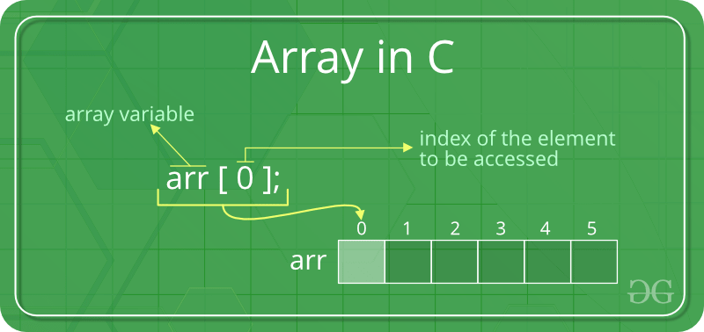 C++

#include <iostream>

using namespace std;

int main()

{

int arr[5];

arr[0] = 5;

arr[2] = -10;

// this is same as arr[1] = 2

arr[3 / 2] = 2;

arr[3] = arr[0];

cout << arr[0] << " " << arr[1] << " " << arr[2] << " "

<< arr[3];

return 0;

}

**Output**

5 2 -10 5

**No Index Out of bound Checking:**

 There is no index out of bounds checking in C++, for example, the following program compiles fine but may produce unexpected output when run.

C++

// This C++ program compiles fine

// as index out of bound

// is not checked in C.

#include <iostream>

using namespace std;

int main()

{

int arr[2];

cout << arr[3] << " ";

cout << arr[-2] << " ";

return 0;

}

**Output**

0 0

**The elements are stored at contiguous memory locations**   
**Example:**

C++

// C++ program to demonstrate that array elements

// are stored contiguous locations

#include <iostream>

using namespace std;

int main()

{

// an array of 10 integers.

// If arr[0] is stored at

// address x, then arr[1] is

// stored at x + sizeof(int)

// arr[2] is stored at x +

// sizeof(int) + sizeof(int)

// and so on.

int arr[5], i;

cout << "Size of integer in this compiler is "

<< sizeof(int) << "\n";

for (i = 0; i < 5; i++)

// The use of '&' before a variable name, yields

// address of variable.

cout << "Address arr[" << i << "] is " << &arr[i]

<< "\n";

return 0;

}

**Output**

Size of integer in this compiler is 4

Address arr[0] is 0x7ffeb5b3c850

Address arr[1] is 0x7ffeb5b3c854

Address arr[2] is 0x7ffeb5b3c858

Address arr[3] is 0x7ffeb5b3c85c

Address arr[4] is 0x7ffeb5b3c860